3/24/2020
Upwey High School
Department of Education and Training
Microsoft Teams
Student Guide

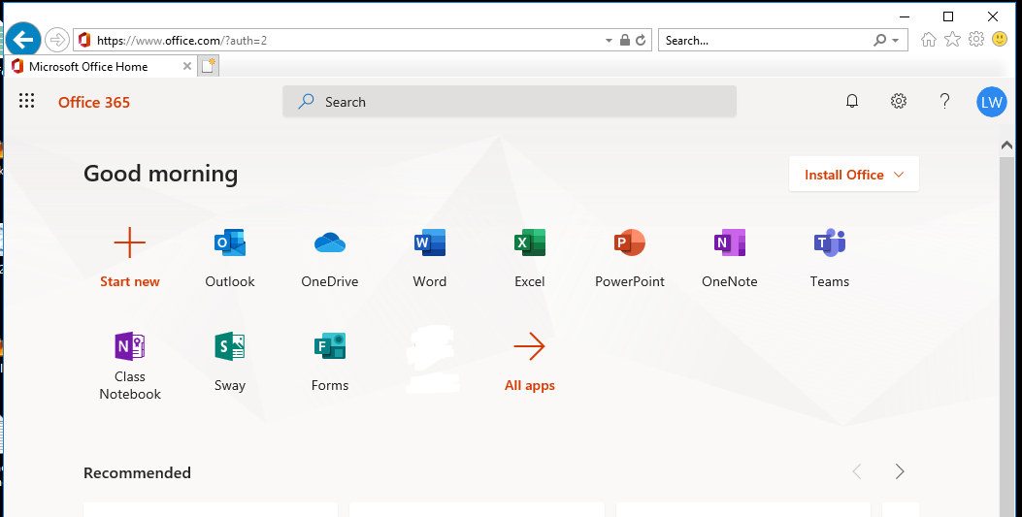
Microsoft Teams is an application used for collaborative work, which includes many features such as, instant messaging, group messaging, video calls, video conferencing, shared work environment, and much more.
Microsoft Teams has been activated for all staff and students at UHS.
To get started, log onto office 365 (email link in daymap/intranet or www.office.com) with your @upweyhs account.
When you hit the landing page of office 365, you will see a Teams icon, click on Teams.

You can use Microsoft Teams on any web browser (chrome is preferred) or download the Microsoft teams app to your desktop/laptop and connect via the application.

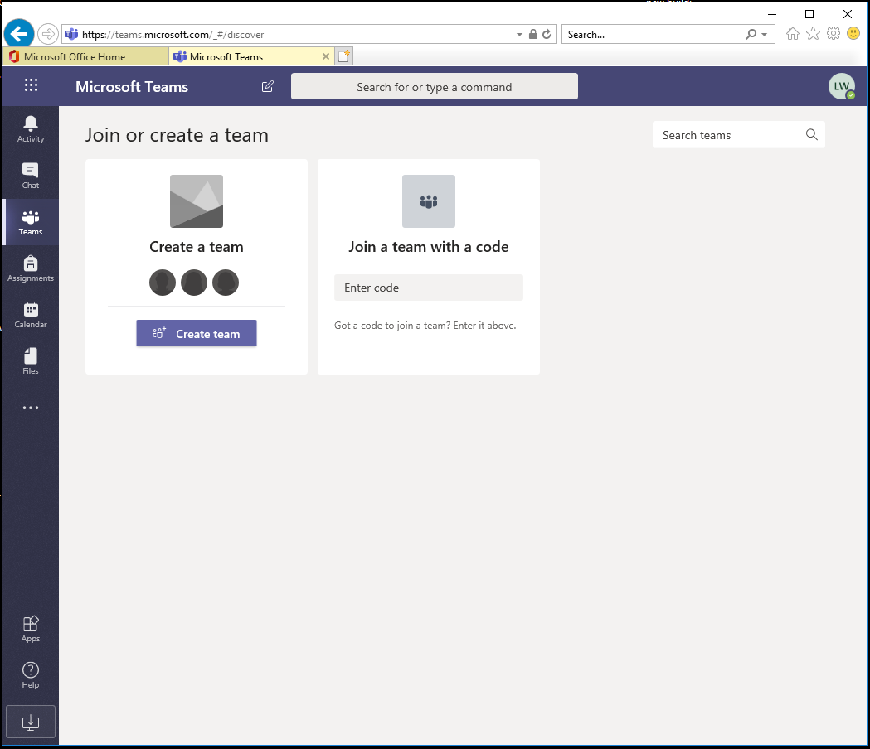
Click to Download and install the Teams App to your desktop
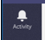The activity tab will show any recent activity related to your account (new teams, new messages, invites etc)
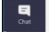The chat tab will allow you to have private one on one chats with other users.
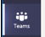The teams tab is where you join and access various teams.
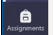The assignments tab will list assignments that have been created or set for you by your teachers (inside Microsoft teams, not linked directly to daymap)
The calendar tab will display your calendar which will link to your outlook calendar, you can schedule meetings here and invite other users, or other teams channels.
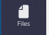The files tab will display links to files inside your onedrive along with files that have been uploaded to teams you are part of.

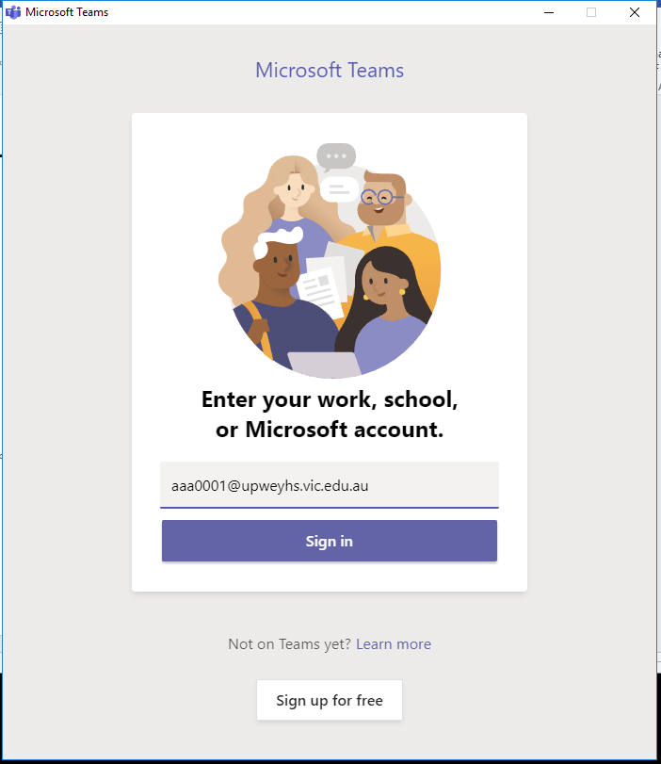
Log in page when using the installed Microsoft Teams application

When a user (student or staff) opens the Microsoft Teams app (installed to your device) you will be prompt to log in, log in using your @upweyhs username and password.
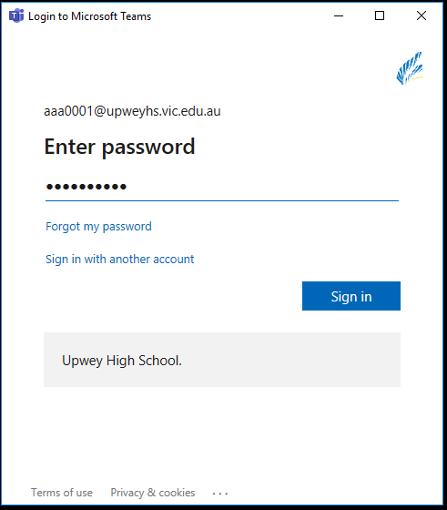
Enter in your @upweyhs.vic.edu.au password and click Sign in.

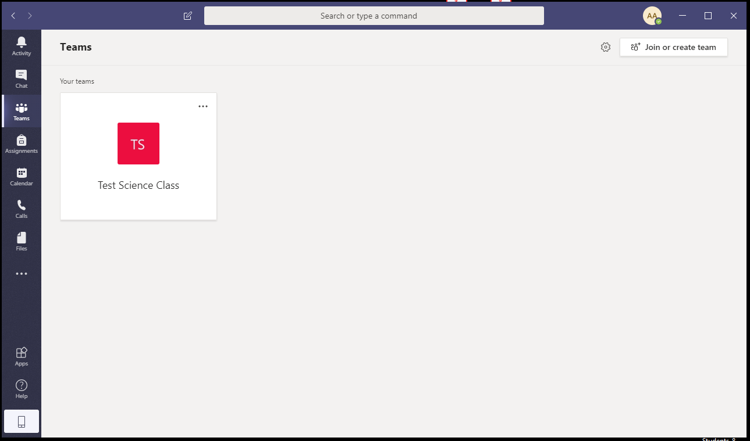
When the app logs in and loads up, you are taken to the Teams tab by default and will list any teams you have been added/invited into.
For example, this student was added to the test science class team by a staff member, so it has automatically joined the student to this team.
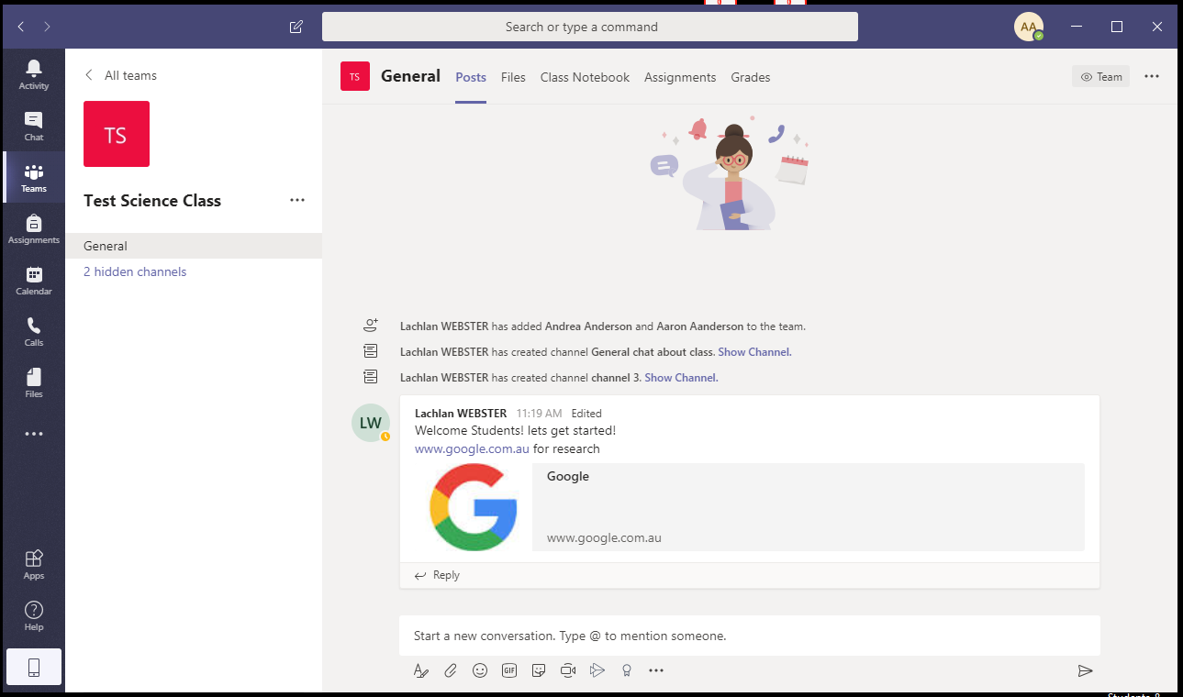
When you click into a team you will be able to see the list of channels inside the team, and their corresponding chat area (with chats, files, links etc)
